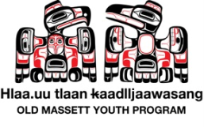

Haida Gwaii Youth Assembly
May 8-10, 2013 Haida Gwaii, BC
Contact: Kiefer Collison,
T: 250-626-3573 F: 250-626-3357 E: kiefer.collison@haidanation.com

REGISTRATION FORM

 | RUN FOR GOVERNMENT | OR | SELECT A TEAM
 | President (1) |  | Fisheries and Haida Fleet
 | Vice-President (1) |  | Heritage and Natural Resources
 | Skidegate Representatives (4) |  | Energy
 | Old Massett Representatives (4) |  | Communications
 | Prince Rupert and Vancouver Regional Rep |  | Culture and Language
*All nominees will be profiled in a Special Youth Election issue of the Haida Laas! |  |  | Fundraising
 |  |  | Secretariat of the Haida Nation
 |  | *Please number your top 3 choices: 1 being the one you want most.

PARTICIPANT INFORMATION
Name | Click here to enter text. |  |  | Age: | M F
D.O.B. | Click here to enter a date. |  | Nation/Village: Click here to enter text.
Contact Information: | Click here to enter text.
E-mail: | Click here to enter text.
Transportation Required: Yes No Accommodation Required: : Yes No

MEDICAL INFORMATION
Medical # |  | Click here to enter text.
Emergency contact Information: |  | Click here to enter text.
Allergies: |  | Click here to enter text.
Physical Concerns/Limitations |  | Click here to enter text.
**A separate waiver must be signed by Parent/Guardian for each Participant under age 19.

TRAVEL INFORMATION  Bus Departs May 7th 2013  Depart QCC City Center 6pm  Depart Skidegate Gas Station 6:30pm  Depart Tlell Post Office 7:00pm  Depart Port Gas Station 7:30pm  Participants will arrive at Englehard’s Hotel for  Check in at approximately 8:30pm | PARTICIPANTS CODE OF CONDUCT  - Role Model Positive and respectful behavior  - Practice common sense and safety  - Show respect for yourself.  - Be pen to a new experience by choosing not to participate in negative activities while at the Assembly.

IMPORTANT NOTE: This form must be completed and submitted separately for each registrant that is aged 13-18 years by Parent/Legal Guardian. Please Print and sign.

PARTICIPANT WAIVER, RELEASE, INDEMNITY AND CONSENT

Please read carefully:
I am aware that, by taking part in the Haida Gwaii Youth Assembly youth event from may 8-10, 2013 offered by the Council of the Haida Nation and the Old Massett Village Council/Youth Program, I may be exposed to the possibility of injury, death, or other losses, including property damage. I willingly accept and assume all such risks, dangers, and hazards associated with my participating in such programs and activities, and the possibility of personal injury, death or loss which may result, directly or indirectly, from my participation. I hereby remise, release and forever hold harmless the Council of the Haida Nation and the Old Massett Village Council/Youth Program its employees, officers, leaders, agents, or representatives from all manner of actions or claims in relation to such risks and any associated injury, death or other loss including, without limitation, where any injury, death or loss is the direct or indirect result of negligence or gross negligence by the such employees, officers, leaders, agents or representatives.
I hereby remise, release and forever hold harmless the Council of the Haida Nation and the Old Massett Village Council/Youth Program from any and all liability for any damage to property of, or personal injury to, any third party resulting from my participation in the recreational programs and activities.
In entering into this agreement I am not relying on any oral, written or visual representations or statements made by the Council of the Haida Nation or the Old Massett Village Council/Youth Program.
I will inform the Council of the Haida Nation and the Old Massett Village Council/Youth Program and any leader or employee as required, of any medical, psychological or physical conditions which may affect my ability to participate in any program or activity.
I confirm that I am aged 19 years or older, and that I have read and understood this agreement prior to signing it, and agree that this agreement will be binding upon my heirs, next of kin, executors, administrators and successors. I agree that this agreement will be governed by and interpreted in accordance with the laws of British Columbia and Canada, as applicable. If the applicant is below 19 years of age, the parent or legal guardian signing consent to this agreement acknowledges and confirms that the applicant may participate in the Haida Gwaii Youth Assembly event offered by the Council of the Haida Nation and the Old Massett Village Council/Youth Program, and that the participant release, waiver, indemnity and consent contained in this agreement applies to and is binding on the parent or legal guardian, and the indemnity extends to include any claim or action brought by any person associated with the applicant, or by any person on behalf of the applicant, or by any third party suffering any loss as a result of the actions of the applicant.
I understand that this waiver will be retained by the Council of the Haida Nation and the Old Massett Village Council/Youth Program and will be valid for one year after the date signed below.
Photograph Release:
I give permission for the applicant’s photograph to be used by the Council of the Haida Nation and the Old Massett Village Council/Youth Program for promotional and reporting purposes:
YES | NO
Participant’s Name : _________________________Participant’s Signature:_____________________________________
Witness’ Signature: ___________________________________________

Parent/Guardian Name: _______________________________________________

Parent/Guardian Signature (if under 19 years old): _________________________________
Phone Number of Parent/Guardian: _____________________________________________
Alternative Emergency Contact Number: ______________________________________________

Date: _________________________________________________

RUN FOR GOVERNMENT: Nomination Deadline April 21st, 2013
- President (1)
- Vice-President (1)
- Skidegate Representatives (4)
- Old Massett Representatives (4)
- Prince Rupert and Vancouver Regional Representatives (youth from prince Rupert and Vancouver please contact your local representatives)
*All nominees will be profiled in a Special Youth Election issue of the Haida Laas!

Elected Youth Representatives will work with our current elected leadership throughout the 3 days of the Youth Assembly.

The Council of the Haida Nation
Top Row L-R: Jason Alsop (Skidegate); Allan Davidson (Vancouver Rep); Pter Lantin (President) ; Trevor Russ (Vice-President); Shaun Cowpar (Skidegate Rep); Shawn Edenshaw (Vancouver Rep)
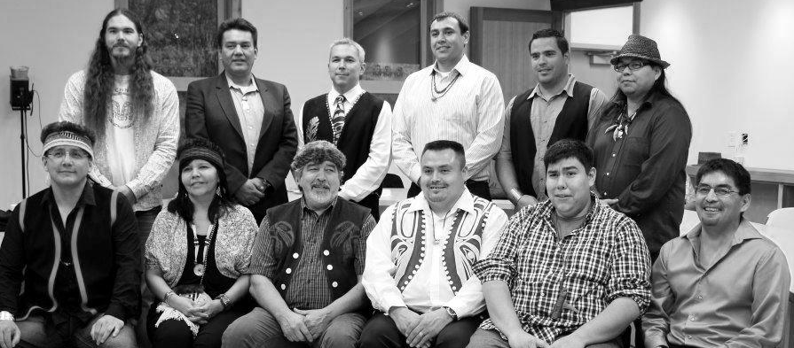
Bottom Row L-R: Percy Crosby (Skidegate Rep); Cynthia Samuels (Ols Massett Rep); Guujaaw (Skidegate Rep); Robert Bennett (Old Massett Rep); Kiefer Collison (Old Massett Rep); Robert Davis (Old Massett Rep)
Missing from Photo: Prince Rupert Regional Representatives
 | Frank Parnell | 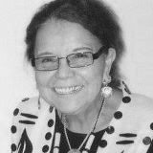 | Pansy Collison

SELECT A TEAM

As part of the Haida Gwaii Youth Assembly, you have the option to select a team. Each team will be appointed a team leader from that organization to guide you through 3 days of real-life scenarios.

Team | Description
- Fisheries and Haida Fleet | This committee deals with political issues such as sports fishing, the quota system for salmon allocations, razor clams, the communal license issues and responding to DFO fisheries policies. The committee’s role is to make recommendations to the CHN.
- Heritage and Natural Resources | The committee is responsible for reviewing and responding to a variety of applications, such as licenses of occupation, land leases, foreshore leases, forestry related applications (road permit, cut permit, salvage etc.) and archaeology related permits and reports
- Energy | The Energy Committee reviews and makes recommendations to the CHN regarding energy issues and projects on Haida Gwaii.
- Communications | This committee focuses on enhancing and expanding CHN communications to people of the Haida Nation and the Islands’ communities.
- 5. Culture and Language | The CHN Culture and Language Liaison provides a link with other organizations and provides political support where required.
- 6. Fundraising | This committee works on raising funds for CHN programs and projects. Fundraising is ongoing and creative individuals are encouraged to join the committee.
- 7. Secretariat of the Haida Nation | The Secretariat of the Haida Nation receives and administers funds on behalf of CHN. Manages human and financial matters of SHN as the legal financial entity of CHN. Annual budgets and contract management.

